Patient |  | Date of Birth
Notes

Locating Bars for indexing THE ALTA DEVICE are indexed to table at
ARMSHUTTLE ELITE Used? | Choose an item. | Armshuttle Hand Grips Indexed at
Armshuttle headrest
indexed at
Vac-Lok Used? | Choose an item. | Vac-Lok Lok-Bar Indexed at

Respiratory Plate Used | Choose an item. If none, skip to respiratory belt section
1) ONEBridge Side A |  | 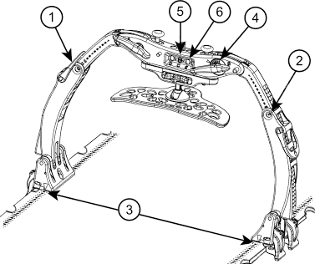
2) ONEBridge Side B
3) Docking Index
4) ONEBridge Lateral Position
5) Respiratory Plate Height
6) Respiratory Plate
Lateral Position
If using ComfortCare Cushion  with Wide Respiratory Plate)  7) Set pressure between | & | 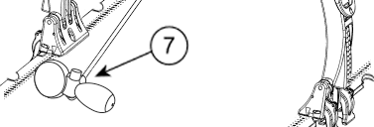

Respiratory Belt Used? | Choose an item. | 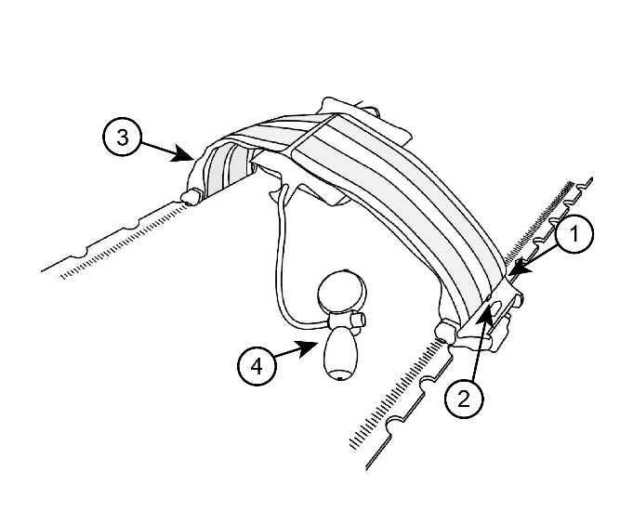
Belt type | Choose an item.
1) left docking index (if applicable)
1) right docking index (if applicable)
2) Left velcro strap indexed at
3) Right velcro strap indexed at
4) Set pressure between | &

Bridge with Clam-Lok  Cushion Used? | Choose an item. | 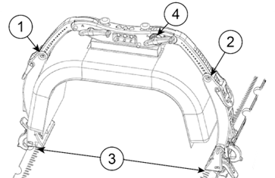
1) ONEBridge Side A
2) ONEBridge Side B
3) Docking Index
4) ONEBridge Lateral Position

KneeFix Used? | Choose an item. | Indexed to Alta Device at
Feetfix Used? | Choose an item. | Indexed to Alta Device at
flexlock knee support used? | Choose an item. | Indexed to Alta Device at
 |  | location of knee support on Locating Bar | Choose an item.

Flexlock feet support used? | Choose an item. | Indexed to Alta Device at
 |  | location of feet support on locating bar | Choose an item.
 |  | Angle of Feet Support | Choose an item.
 |  | leg and Foot Strap used? | Choose an item.
Additional indexable accessory |  | Indexed to Alta Device at
Additional indexable accessory |  | Indexed to Alta Device at

Patient hAND GRIPS USED? | Choose an item.
rIGHT HAND GRIP INDEXED AT |  | lEFT HAND GRIP INDEXED AT

