Pro Wing Board™ |  | 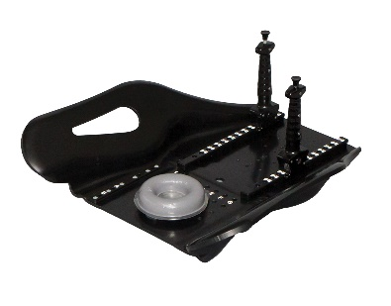
Patient |  | Date of Birth
Notes

- Lok-Bar™ indexed to table at

 | 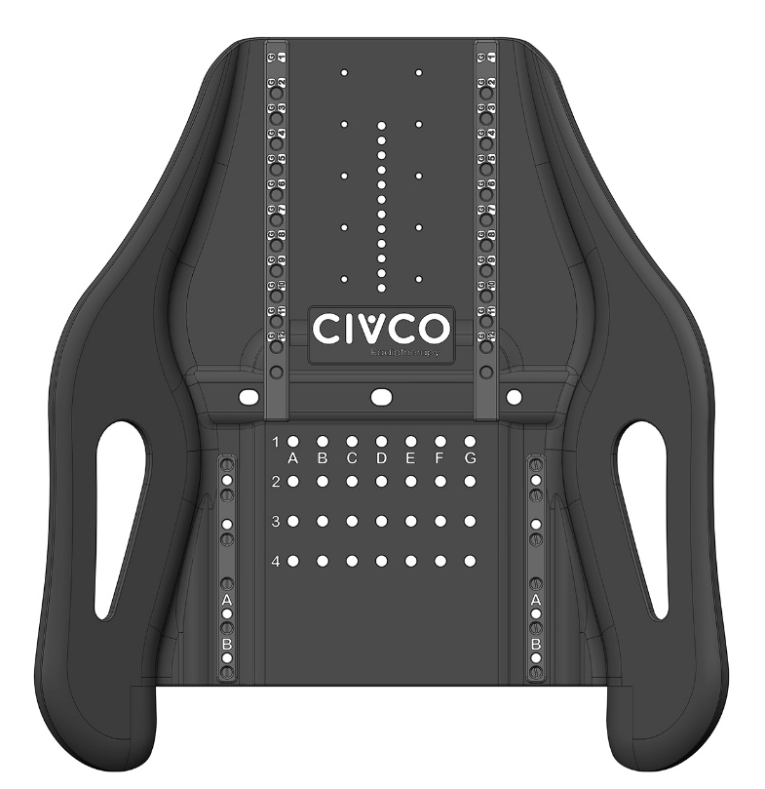
- Headrest type |  | Indexed at
- Handle type |  | Indexed at | Left: | Right:
- Chin Thermoplastic used? | ☐ Yes ☐ No | Indexed at | ☐ A ☐ B
- Vac-Lok™ used? | ☐ Yes ☐ No

